Vision and Scope Document

for

Air Supply-Pilot

Version 1.0 approved

Prepared by

12 October 2018

Table of Contents

Table of Contents ii

Revision History ii

1. Business Requirements 1

1.1. Background 1

1.2. Business Opportunity 1

1.3. Vision Statement 1

1.4. Business Assumptions and Dependencies 1

2. Scope and Limitations 1

2.1. Major Features 1

2.2. Scope of Initial and Subsequent Releases 2

2.3. Limitations and Exclusions 3

3. Business Context 3

3.1. Stakeholder Profiles 4

3.2. Deployment Considerations 4

Revision History

|  |  |  |  |
| --- | --- | --- | --- |
| **Name** | **Date** | **Reason For Changes** | **Version** |
| Vision and Scope Document for AS-P | 12/10/18 | Original | 1.0 |
| - |  |  |  |

# Business Requirements

## Background

An ongoing issue faced by a large number of clinics in Hong Kong is the space taken up by inventory of medical supplies. Clinics in Hong Kong consume medical supplies at a relatively slower rate compared to major hospitals, especially when it comes to specialised medication. Hence, the storage of medication takes up an unnecessarily large amount of space. Additionally, these medication have limited shelf-life and can lead to unnecessary wastage when their expiry dates are reached. However, clinics need to maintain their inventories in order to accommodate to varying patients’ needs.

## Business Opportunity

To address the issue of using excessive amounts of space to store medical inventory in Hong Kong clinics, endorsing the use of a drone delivery system to send medical supplies on demand would significantly reduce storage space which can be utilized for more operational needs. These supplies could be centralized in major hospitals where storage space and having large amounts of both generic and specialised medicine would be less of an issue. The ability to deliver medicine using aerial transportation would not only be beneficial on a day-to-day basis but also be useful in dire situations such as after natural disasters because it eliminates the need of ground transport. This is especially favourable for residents of outlying islands where major hospitals are not easily accessible.

## Vision Statement

For Hospital Authority who wishes to centralise warehousing and distribution of medical supplies, the AS-P is a single self-contained web application that provides basic ordering by clinics, loading planning and route planning services.

Unlike the current inventory management in clinics that maintain their own inventories of medical supplies, AS-P will centralize warehousing at Queen Mary Hospital to minimize the storage space in the clinics that are occupied by the inventories. AS-P will also reduce unnecessary wastage of medical supplies with limited shelf-life as the rate at which clinics consume them is comparatively low.

## Business Assumptions and Dependencies

AS-1: Hospital warehouse always has sufficient stock to satisfy all orders.

AS-2: Clinic managers specify true priority when ordering.

AS-3: Clinic managers notify the system as soon as orders are received.

DE-1: Email will be delivered instantly.

DE-2: Storage space of the email account will always be sufficient.

DE-3: Drone will always have reliable navigation.

DE-4: Drone service will always have sufficient battery to travel the longest possible route.

DE-5: Quantity of drone is sufficient to handle the expected volume of orders.

DE-6: Quantity of battery for drones will always be sufficient.

# Scope and Limitations

## Major Features

FE-1: Create and modify accounts for various users such as clinic managers, warehouse personnel, administrative staff, etc. with varying features for each user group.

FE-2: Browse through supplies that are available and their respective descriptions (including images, weight and other additional details) for drone delivery.

FE-3: Place and cancel orders from Queen Mary Hospital warehouse.

FE-4: Update and monitor each phase of the order throughout the process in real-time.

FE-5: Effectively route locations where supplies need to be sent sequentially and allocate which packages will be sent on which drone.

FE-6: Automate the queue systematically based on predetermined limitations.

FE-7: Maintain and archive completed orders for audit purposes.

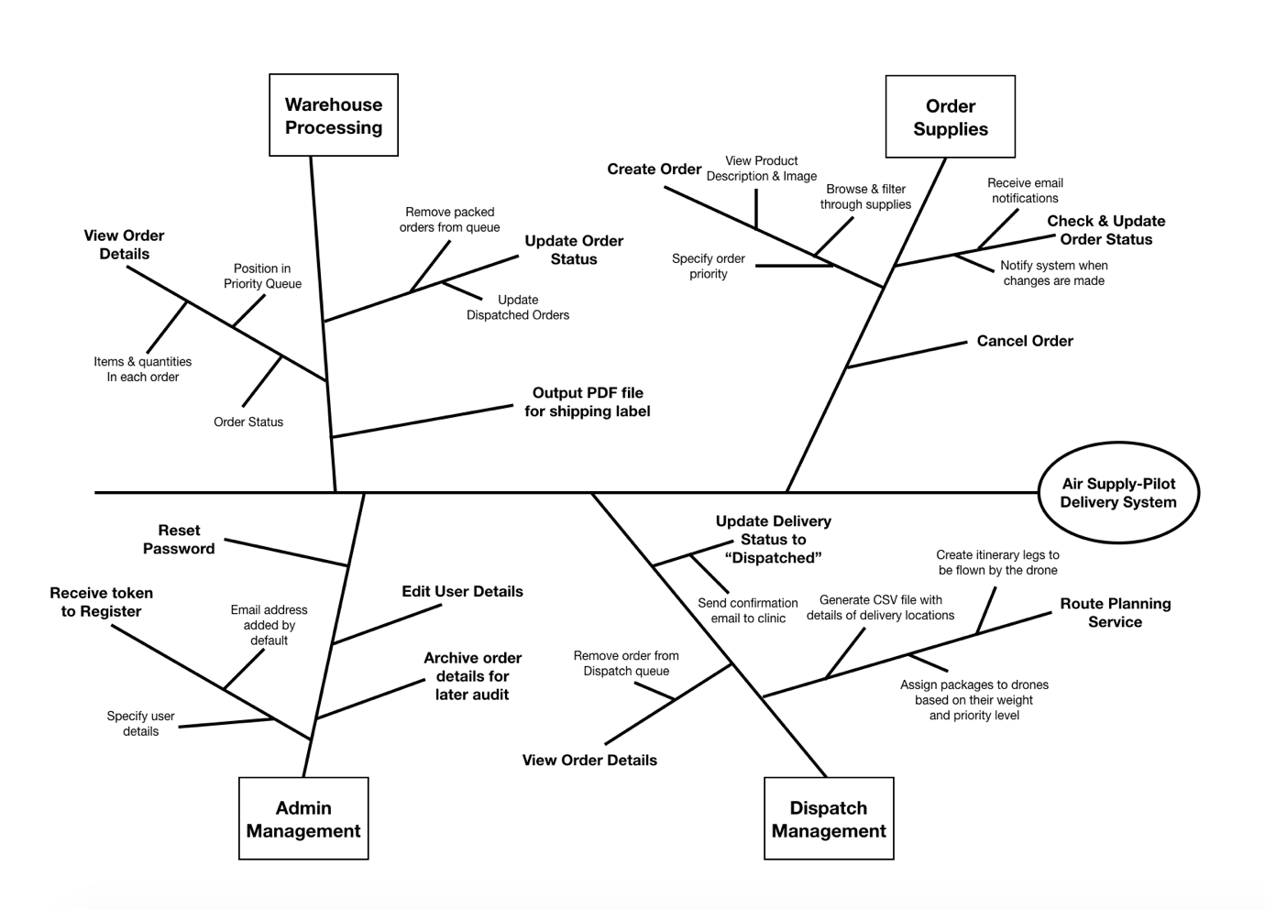

**Figure 1.** Feature tree of Air Supply-Pilot.

## Scope of Initial and Subsequent Releases

|  |  |
| --- | --- |
| **Feature** | **Release 1** |
| FE-1, Account registration | Create accounts through token sent to each user’s respective email. Users will be asked to provide username, full name and password. Editing and retrieving accounts can be done once user is registered. |
| FE-2, Browsing through item details | Fully Implemented |
| FE-3, Placing supply orders | Users can add items to the cart & specify the item quantity and order priority. |
| FE-4, Order Processing Status | Update order status and remove orders from queue depending on the stage of the process. |
| FE-5, Route planning service | Fully Implemented |
| FE-6, Queue Automation | Sort orders in the queue for warehouse processing and dispatching based on priority and weight limit. |
| FE-7, Archives | Fully Implemented |

## Limitations and Exclusions

LI-1: The system will not retain information of ongoing orders that are not completed when the user logs out or a network failure occurs.

LI-2: Features for adding new products into the catalogue will not be implemented in the initial pilot system. Admin will have to add products inventory manually.

LI-3: Supplies are packed manually by Warehouse Personnel and these packages are also loaded manually onto drones.

LI-4: File containing itinerary for drone delivery has to be uploaded manually by dispatcher onto drones.

# Business Context

## Stakeholder Profiles

|  |  |  |
| --- | --- | --- |
| **Stakeholder** | **Major Value** | **Major Interests** |
| Hospital Authority | Cost savings in inventory space and wasted medical supplies; Reduce number of clinic staff to manage storage; Easy auditing | Cost savings must exceed development and usage costs |
| Queen Mary Hospital Warehouse Personnel & Dispatcher | Increase productivity and time efficiency in delivering medical supplies | Minimal new technology needed; simplicity of use |
| Clinic Manager | Reduce unnecessary wastage of medical supplies; More reliable compared to ground transport during urgent times. | Minimal new technology needed; simplicity of online ordering |
| Clinic Staff | None identified | Job preservation |

## Deployment Considerations

The access to the system is only limited to users who have a Hospital Authority email address Users are distributed across Southern District and the Islands of Hong Kong in the same time zone. Clinic Manager, Warehouse Personnel, Dispatcher and Hospital Authority will need to access the system to place an order, process queue of orders, load order(s) to a drone and view order history respectively. Users will require active Internet connection to access the AS-P. AS-P will be built with SQLite as its DBMS, and it will be embedded with the browser. The web server software will need to be upgraded to the latest version. Any corresponding infrastructure changes must be in place at the time of the release. Training is needed for Warehouse Personnel and Dispatcher to ensure full understanding of the flow of the system.